Assignment 3
Portfolio Sitemap

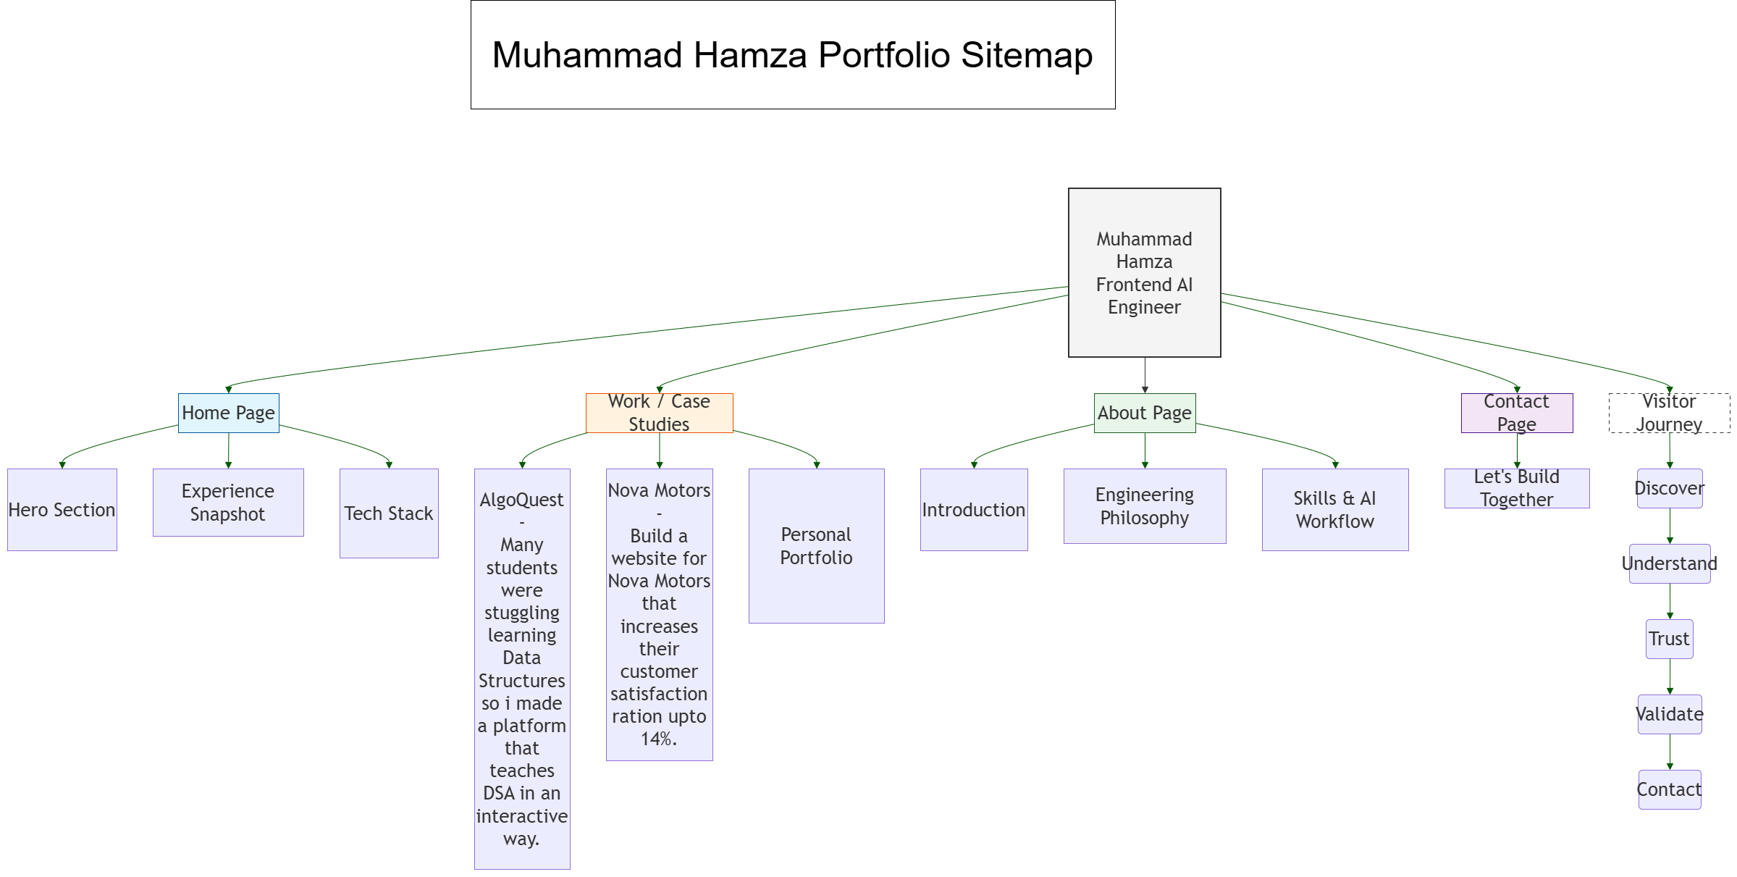

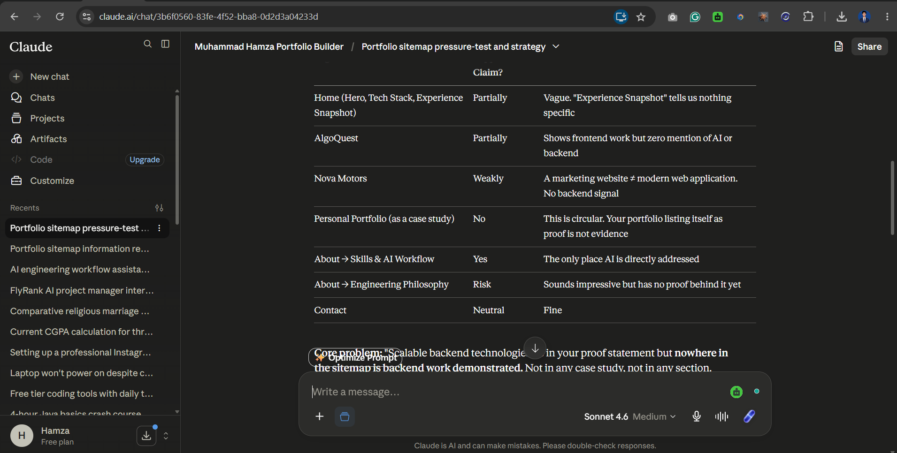

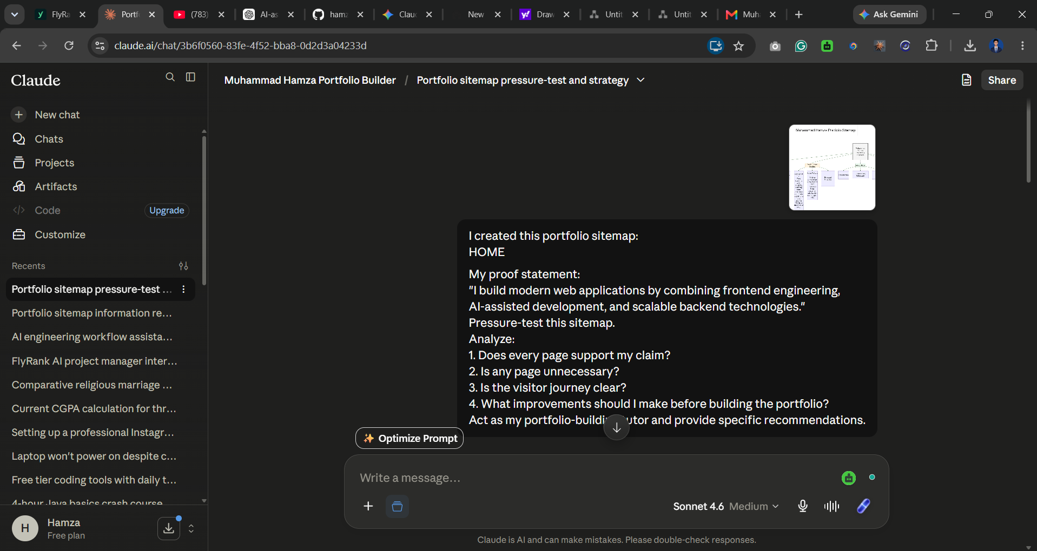

Claude Feedback Applied:

After reviewing my sitemap, Claude suggested that my case studies
should focus more on:
- Problems solved
- Engineering decisions
- Technical challenges
- Impact/results

I will use this structure when building the final portfolio.

